Generative Design Colour Experiment

Timothy Roberts – N00150074

# Theoretical Basis

The aim of this colour experiment was to demonstrate colour interpolation in a visually exciting way. Where movement and shape within colours could take form in a relatively unpredictable manner, yet having the relationship of the colours pleasing enough to the eye so that it amalgamates these impulsive shapes into a more structured piece.

A real-world example of colour interpolation that elicited this basis was the nature in which paints blend as they are mixed into a container prior to being stirred.

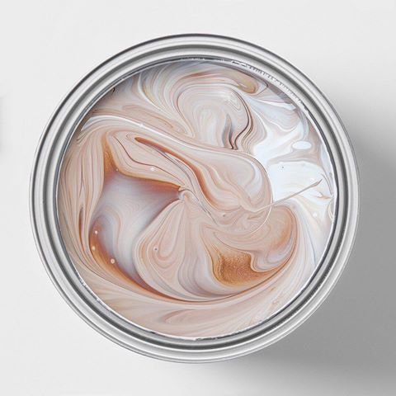

Figure An example of colour interpolation in unstirred paint

Colour is an extremely powerful tool in art and design. It is used to evoke an emotional response from an audience. The objective was to create an effect similar to this unstirred-paint look in *Figure 1* where any two colours could be chosen to interpolate into this style. Experimenting with colours to find a combination that would represent a generative design book on colour well, and that would evoke curiosity from the viewer about the world of colour and generative design would then follow.

# Algorithmic Basis

A flowfield is a grid of vectors, each with an individual angle ranging from 0-360 degrees. This angle is calculated using perlin noise, a smooth randomness that insures that the angle doesn’t differ dramatically from its surrounding angles. These vectors are then drawn as lines which displays the shape of the flowfield that particles will follow.

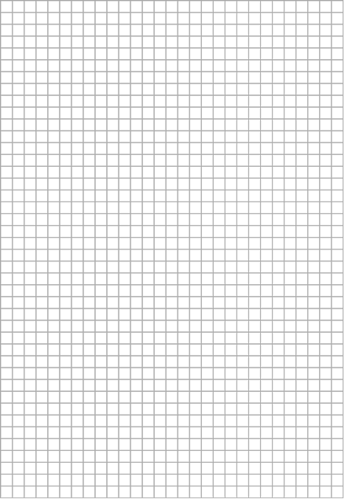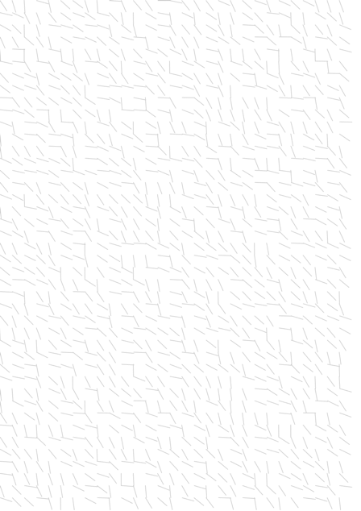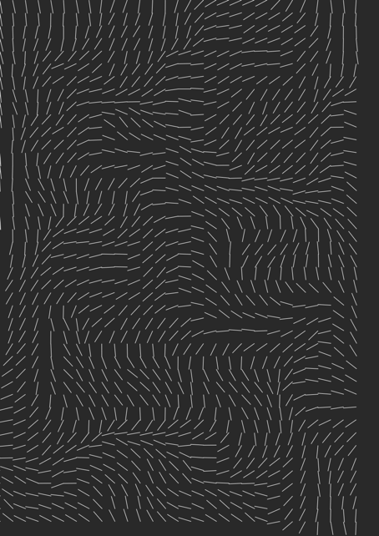

Figure Grid, vectors drawn at a random angle, vectors drawn at an angle using perlin noise

To understand the theory of constructing a flowfield, I followed a tutorial by Daniel Shiffman (<https://www.youtube.com/watch?v=BjoM9oKOAKY>). Rather than having a flowfield where the vectors were constantly in motion in relation to perlin noise, a class was created in order to update the motion of the flowfield only by calling the classes function *generate*. This was so that the flowfield would only change when a new particle was introduced to the sketch.

# Colour Theory

With the brief centring around colour, it was important to use colour relationships that worked well together. Primary or secondary colours were decided upon, and the interpolation of colour would tween (gradually blend) towards its neighbouring tertiary colour. Analogous colours are the name of these colours that appear close together on a colour wheel. If we look at *Figure 3* blow, an example of an analogous colour pallet would be orange (secondary colour), and red-orange or yellow-orange (tertiary colours).

A subtle highlight layer of colour is used to accent these analogous colours in the program. Complimentary colours were used as this highlight layer, which are located on the opposite side of the colour wheel. For example, once again using *Figure 3* below, we can see that the complimentary colour for yellow-green would be red-violet.

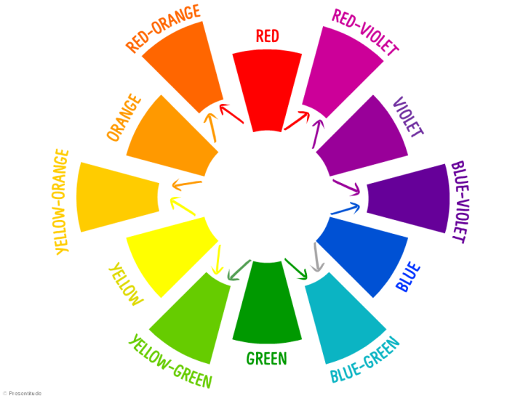

Figure 3 Tertiary colours on a colour wheel (in-between primary and secondary colours)

# Available to the User

The user is provided with 11 colour combinations (A mix of 5 analogous colour relationships, and 7 complimentary colour relationships) which can be accessed by the keyboard. A legend was created for the user to see which key activates which colour relationship.

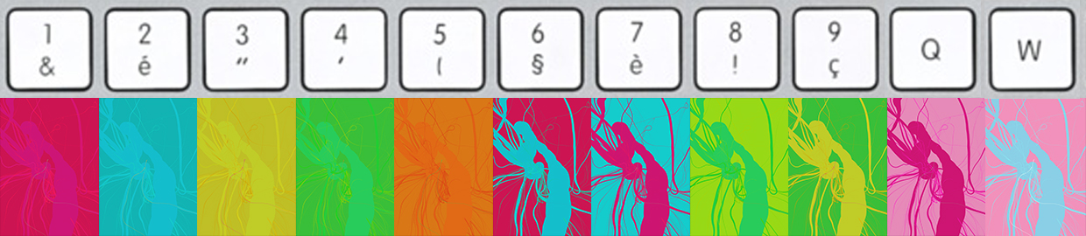

Figure 4 Colour legend in application

Magnitude is a variable within the program that defines the intensity in which the paint layers follow the underlying flowfield. A slider was created so that the user could adjust and experiment with the magnitude between -1.08 and 1.08 to create varied results.

# Conclusion

There is some functionality in the program that could still be fine-tuned and developed further. An example of this is when the magnitude is higher, it is clear that the functionality to draw a line between previous and current points does not work as it should (see *Figure 4* below).

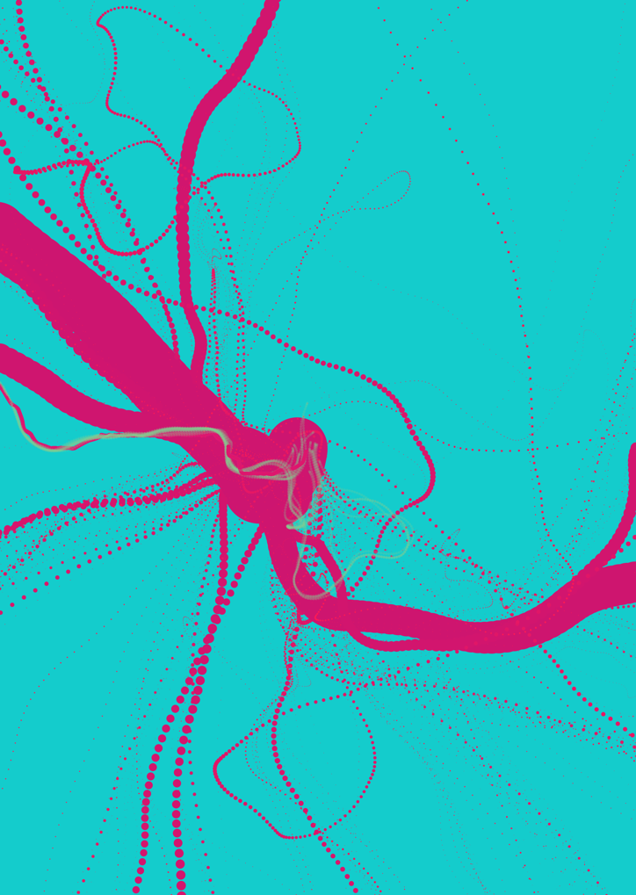

Figure Joining points problem

While this is not creating the desired outcome, this effect is still an interesting result and may invite potential customers to think about how this book cover is being drawn.

Aside from this issue, I feel satisfied with the outcome of this project. There were challenging aspects to creating a paint-styled flowfield with interpolating colour layers, but overall the finished piece matched the imagined outcome, and succeeds in evoking an interest into the world of colour in generative design. See the finished piece below (*Figure 6*).

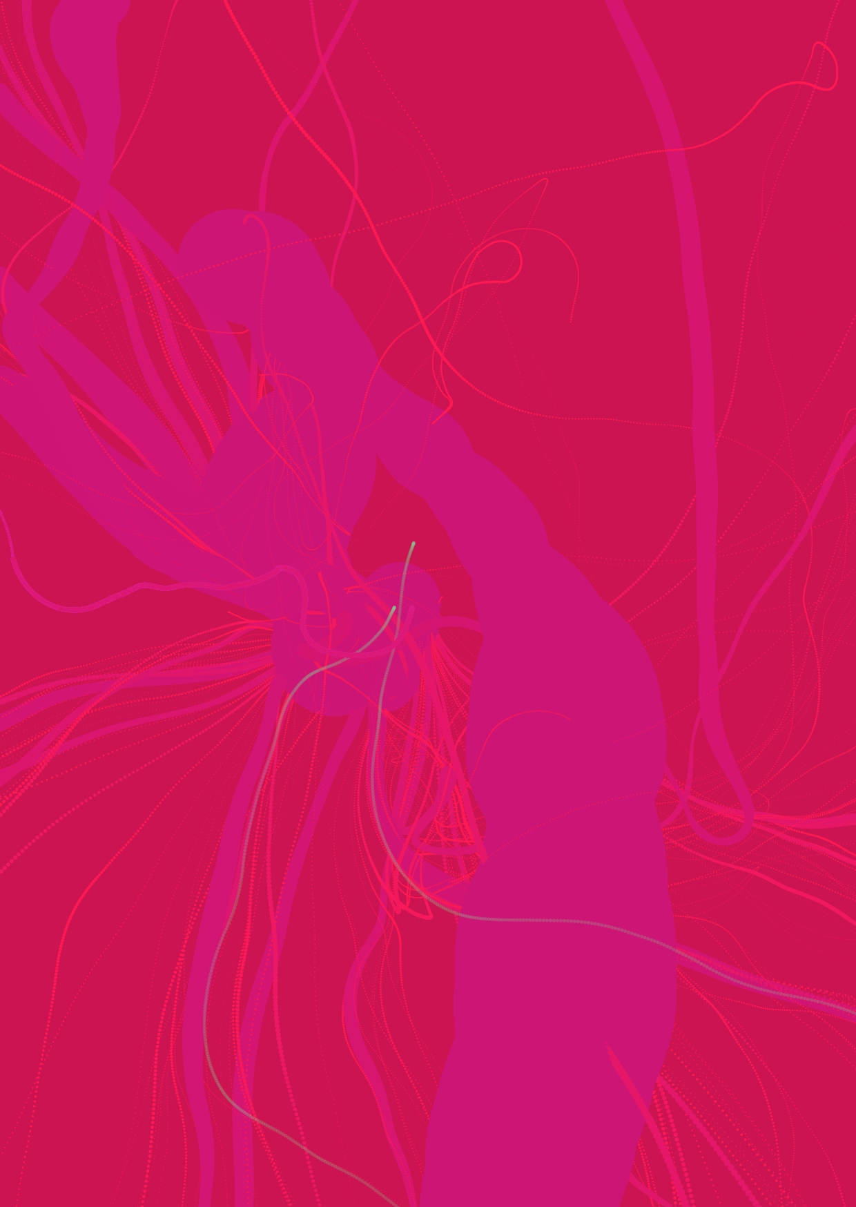

Figure Colour in Generative Design book cover (White text would be used for title and author)